English 11 Summer Reading Assignment
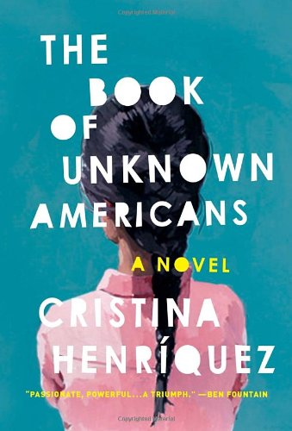
- All students must read The Book of Unknown Americans by Cristina Henriquez.

Summary of The Book of Unknown Americans from the publisher:

A boy and a girl fall in love. The hopes of two families collide with destiny. After fifteen-year-old Maribel sustains a terrible injury, the only hope her family sees for her recovery lies in the United States. Leaving a comfortable life behind in Mexico, the Riveras risk everything to come north. It’s not long after they settle that Mayor Toro, the son of one of their new neighbors, recognizes a kindred spirit in this beautiful, damaged outsider. Their love story sets in motion events that will profoundly affect the pair of star-crossed lovers and their two families. Resonant with the hopes and dreams, guilt and love of men and women from all over Latin America who have come to the United States, The Book of Unknown Americans is a stunning novel that gives us a new definition of what it is to be an American.
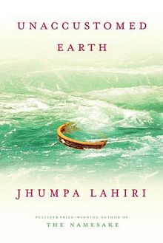

- For honors credit, students must also read Unaccustomed Earth by Jhumpa Lahiri.

Summary of Unaccustomed Earth from the publisher:

Beginning in America, and spilling back over memories and generations to India, Unaccustomed Earth explores the heart of family life and the immigrant experience. Eight luminous stories – longer and richer than any Jhumpa Lahiri has yet written – take us from America to Europe, India and Thailand as they follow new lives forged in the wake of loss.

As you read, keep a typed journal of your experience reading the book. For each book, you must write three entries (so you should have six total if you’re trying to get honors credit). Each entry must:
- start with a quote of at least one complete sentence from the book.
- be at least 250 words long, not including the quote.
- include some analysis or personal connection to the quote, not merely summary.

Here are some suggested prompts, but you may come up with your own:
- Find a passage that looks or sounds beautiful to you. What about the author’s choice and arrangement of words make this passage beautiful?
- Identify a recurring theme or motif in the book. What is its significance?
- What is your opinion of a particular character? Can you relate to this character? Do you sympathize with this character?
- Is there a particular situation that resonates with you because of your own experiences?

You will quickly notice that immigration is a theme in both books. It doesn’t take a stretch of the imagination to recognize that CCSC’s own network of family and friends makes up a mosaic of immigrant voices. Therefore, in addition to writing the journal, please interview an immigrant currently living in the U.S. The interviewee can be a member of your immediate family, relative, friend, classmate, co-worker, etc. You may want to audio or video record the interview so that you can easily complete the written portion of the assignment afterwards. If the interviewee is more comfortable using a language other than English that you also speak, you may conduct the interview in that language and translate it to English later. The final product you are submitting is a transcript of the interview as well as a reflection about the interview.

The transcript should:
- include a note at the top explaining the date and location or method (if not in-person) of the interview, the interviewee’s name, your relationship to the interviewee, when and from where the interviewee came to the U.S., and, if applicable, translation information.
  - Example: Jee-Hyun Song interviewed her mother, Michelle Song, via phone on July 30, 2016. Michelle came to the U.S. from Korea in the summer of 1996. The following transcript of the interview has been translated from the original Korean by Jee-Hyun.
- include at least ten thoughtful questions and the interviewee’s responses to those questions. The point is to allow the interviewee to tell his or her story.
  - Example:
    - JS: What was the most difficult challenge you faced in the months after you arrived in this country?
    - MS: I couldn’t speak English well, so I felt very helpless. I could only bring my children to school, pick them up from school, and cook and clean for my family. All my friends and family were in Korea, and I didn’t know anyone in New Jersey, so I felt very lonely.

The reflection should:
- be at least 350 words long.
- describe your experience of conducting this interview and connect your interviewee’s experiences to those of the characters in one or both summer reading books. How did you feel while conducting the interview? Did you learn anything about the interviewee that surprised you? What patterns do you see in the lives of real immigrants in this country and the characters in the summer reading books?

Type and print all summer reading materials and bring them to class on the first day of school. Make sure you have checked your writing for spelling, grammar, and punctuation errors. The journal will be your first major assessment grade, the interview your first minor assessment grade. Happy reading!

