Name: ______________________________  Date: _______________________________ | Rising 6s Summer Reading  Maniac Magee
Summer Reading
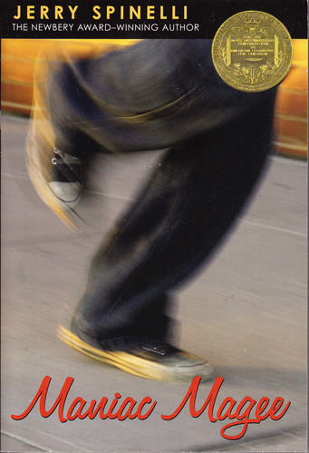
Required Reading: Maniac Magee
This summer, you get to read Maniac Magee by Jerry Spinelli. It’s a book about love, fear, home, baseball, prejudice and understanding. It’s a great book that we hope you’ll enjoy.

While you read, please use sticky notes and keep track of your favorite quotations, your questions, and your comments. Or, you can feel free to write directly in this book because it is yours.

After you’re finished reading, you will need to complete what we call a Letter Essay. The specifics of the letter are described on the back of this sheet, paragraph-by-paragraph. This is a letter, so write it in that form, starting with “Dear Humanities Teacher,” and then closing by signing your name at the end. Please type or neatly handwrite this letter, and be ready to turn it in on the first day of school.

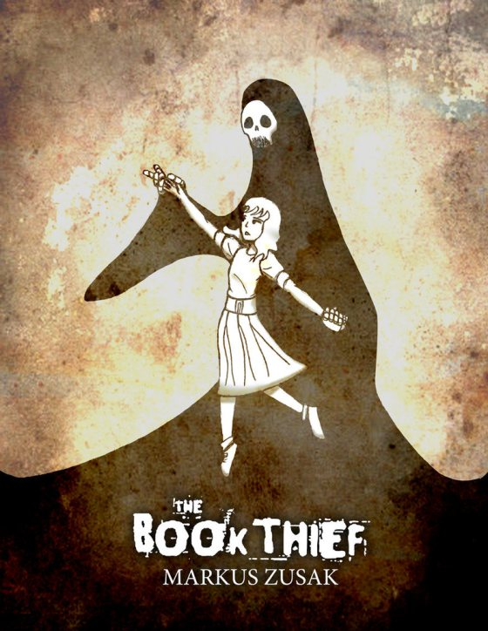
Honors Reading: The Book Thief
The honors reading book this summer is The Book Thief. This is a well-written and intense book—an unforgettable story.

It is 1939. Nazi Germany. The country is holding its breath. Death (the narrator) has never been busier, and will become busier still.

Liesel Meminger is a foster girl living outside of Munich, who scratches out a meager existence for herself by stealing when she encounters something she can’t resist—books. With the help of her accordion-playing foster father, she learns to read and shares her stolen books with her neighbors during bombing raids as well as with the Jewish man hidden in her basement.

If you choose to read this book, please use sticky notes to keep track of your favorite quotations, questions, and comments. You can also feel free to write directly in this book as well. If you choose to do the honors assignment, you do not have to write a letter essay for this book, but you must come to the first day of school ready to discuss this book with your teacher and your peers.
Letter Essay Instructions

Paragraph 1: Introduce yourself and who you are as a reader. Your description could include: the number and type of books you’ve read this year, your favorite book, what you love or hate about reading, who your favorite author is, or your favorite storybook to listen to as a child. Don’t feel like you need to write about each of these in your description, but do your best to describe who you are as a reader to your Humanities teacher.

Paragraph 2: Introduce the book, Maniac Magee, and write a brief summary of the it. Introduce the characters, setting, and what the main problem is (conflict). A great summary quickly retells the main points in a way that engages the reader, so as a writer you need to stick to the most important points in order to provide a preview for your reader. Please summarize the text in ten sentences or less.

Paragraph 3: In this paragraph talk about the writing of the book (the form). Give an example of text that you love from the book (that means find a quote from your book and put it into this paragraph). Comment on why you chose this quote. Tell what is good or bad about it. Point out what the author has done that made you want to continue to read. The quote needs to be significant, and you need to be able to explain why you like the text that you chose.

Paragraph 4: Tell what genre this book is, and give it a rating. Explain why you have rated it as you did and who you would or wouldn’t recommend it to.

Paragraph 5: In this paragraph, name and describe the theme of this book. Theme is the big idea or main message in the story (ex. overcoming challenges, love, perseverance, hope, growing up, identity, culture, prejudice, poverty, choices, good and evil). Theme is not the author’s purpose or the topic of the text. Theme isn’t intended to teach or preach—usually it is not presented directly at all. Theme is what we, as readers, begin to think about when we put together what the characters do, say, and think in a book. In this paragraph, you need to name both the theme, and support it with specific textual evidence, elaborating on your ideas.
Name: ______________________________  Date: _______________________________ | CCSC  Letter Essay Rubric

Below is the rubric that your teacher will use when he or she grades your letter essay. Please read through this before you start to write so you know what is expected of you.

 | 4: Advanced | 3: Proficient | 2: Developing | 1: Emerging
Demonstration of Text Understanding | Show multi-dimensional understanding of text | Shows adequate understanding of text | Shows some understanding of text | Shows no understanding of text
Voice/Personality | Uniquely expressed and interesting to read | Contains few interesting parts | Mostly dull | Trite + empty
Clarity of Expression | Uses language very effectively to communicate ideas | Uses language adequately to communicate ideas | Shows some difficulty using language to communicate ideas | Is unable to use language effectively to communicate ideas
Use of Conventions (CUPS) | Uses conventions accurately so response is easily understood | Uses adequate conventions so response is mostly understood | Uses a few conventions so parts of response are understood | Uses almost no conventions so writing is difficult to read and understand
Awareness of Self as Reader and Writer | Shows high level of awareness of self as reader and/or writer | Shows adequate awareness of self as a reader and/or writer | Shows little awareness of self as a reader and/or writer | Shows no awareness of self as a reader and/or writer

